**PharmGenius Walkthrough**

The following document will give an overview of the PharmGenius web application and a basic walkthrough of the pages within the site.

**Overview**

As of this writing, the PharmGenius application has been worked on by three different capstone groups dating back to Spring 2016. Dr. Ravi Patel of the University of Pittsburgh School of Pharmacy is the primary stakeholder for the project.

Pharmacists are required to complete a mandatory number of hours of ongoing training every year, and Dr. Patel was interested having some way that pharmacists would be able to complete said training in a more fun and interactive way. The idea was to develop a quiz game application that could be used to allow pharmacy students to test their knowledge, with long-term goals of being able to data aggregation and reporting on data collected by the application.

Prior to the Spring 2017 semester, the application was deployed on Google App Engine (as of this writing, site is still live at <http://pharmgenius.com>). Google App Engine provided the previous groups with certain advantages, chief of which being that it was free to use, but stakeholders felt that some of the limitations of hosting the site on Google were detrimental to the overall growth and usability of the application. Some of these issues were inflexibility, lack of control over the data (abstraction of database details) and the reliance on Google account management. The decision was made to migrate the application off of Google App Engine and onto PHP and MySQL technology so that the site would eventually be able to be hosted on Pitt UNIX based servers. This process ended up taking up a good deal of the semester (in fact, not every page was successfully migrated) and was the primary focus of the Spring 2017 capstone group.

**Existing State of the Application**

While the application is not currently deployed to a live server, the application currently exists in a usable state. See the document entitled “PharmGenius Development Installation Guide.docx” for how to install a local copy of the application to your machine.

Currently there are three pages that do not function as they did on previous version of application. These pages are review_my_questions.php, review_new_questions.php, and review_old_questions.php. The group simply ran out of time and was unable to get these pages implemented. They do exist in a non-functional state, but would be the first target for updates by future groups. In reality, they should not be terribly difficult to implement, and are similar enough to each other that completing one should allow the other two to fall into line rather easily. I somewhat lament that I need to write this documentation instead of working on getting those implemented, but anyone reading this should take this as an opportunity to familiarize yourself with existing application code and design while fixing these pages.

There were three primary challenges faced during the Spring 2017 semester. Creating a database (basically from scratch using existing data from the Google App Engine version of the application) to house the data for the application, creating a user account system that would allow the application to not rely on Google accounts, and actually migrating the code from a Python/Django based architecture onto PHP and MySQL.

The Spring 2017 group was successful in navigating all of these challenges (the three non-implemented sites not withstanding). The application exists in a functioning state, with the most important functionality (user account management, quiz taking, category/quiz/question creation) all implemented well. Of course, there is always room for improvement.

**Site Walkthrough**

***Landing page – index.php***

Upon first visit, users will see the below screen. The down arrow will take the user to an About section with some basic information about the site. The Sign In link will take the user to the login page.



***Login page – login.php***

This page will allow the user to log in to the site, or the user can click the “Create Account” link to be taken the create account page. This is also where users will be redirected to if they attempt to access pages on the site without being logged in.

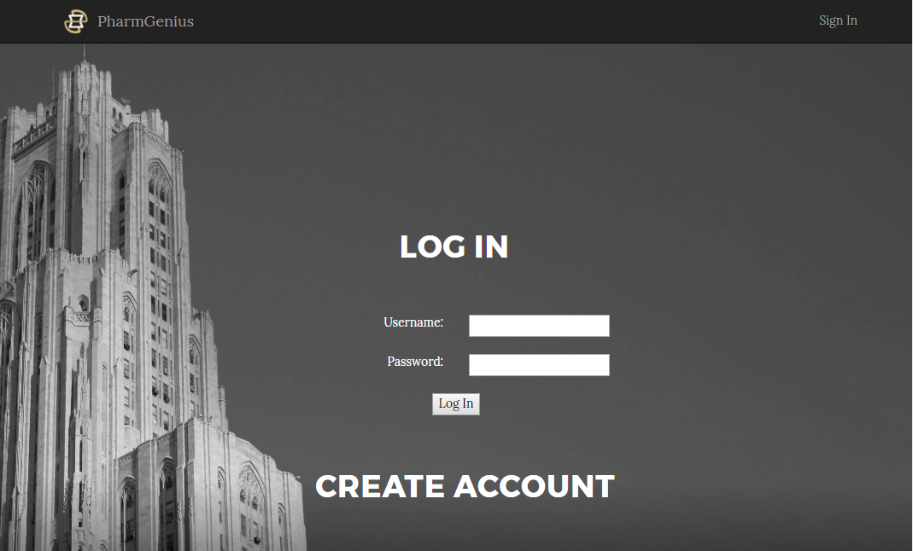

***Create Account – create_account.php***

Here users can create an account with which to log into the site. There are basic validations present to prevent a user from creating an account with a username that is already taken, ensure the passwords match, etc.

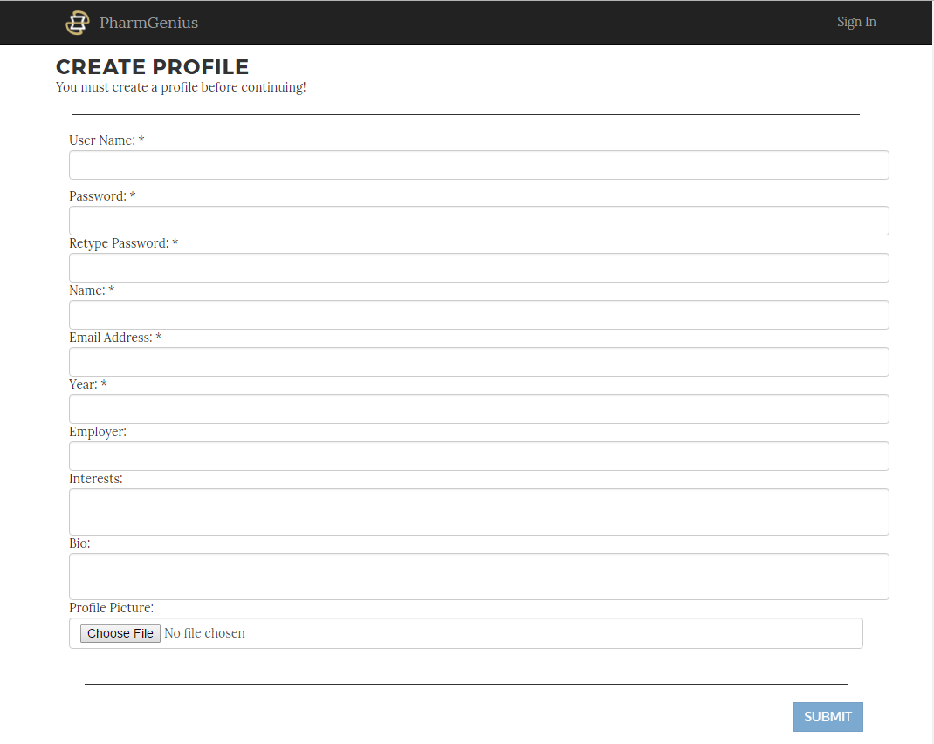

***Landing Page Once Logged In – index.php***

Once a user is logged in to the site, they will be redirected back to index.php and will be presented with more options on the navigation bar. The down arrows have also changed to a right arrow (reminiscent of a play button on a media device) that will now take the user to the select quiz page of the site. Note that the picture includes a dropdown menu for Admins. This is only present if the user is flagged as an admin in the site’s database.



***Select Quiz – select_quiz.php***

By clicking the “Quiz Me!”, users will be taken to the select quiz page where they can choose a category, quiz, number of questions, time per question, and whether or not to only see their own submitted questions. Then, by clicking the Start Quiz button, the user will be taken to the main quiz page.

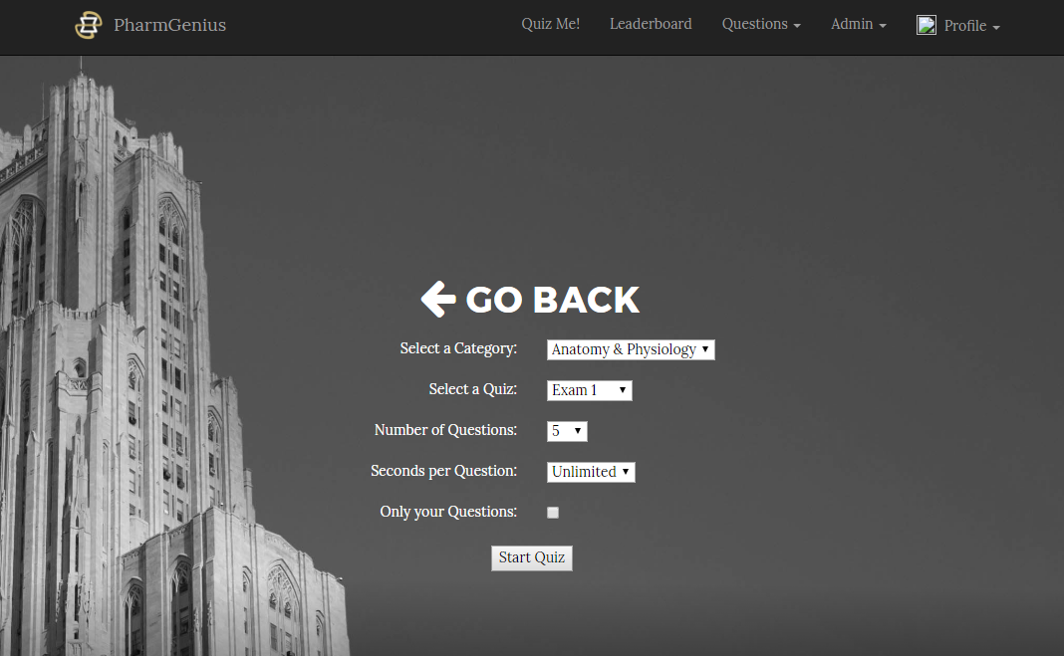

***Take Quiz – take_quiz.php***

If the selected quiz does not have any active questions, the user will be present with the following popup to redirect them.

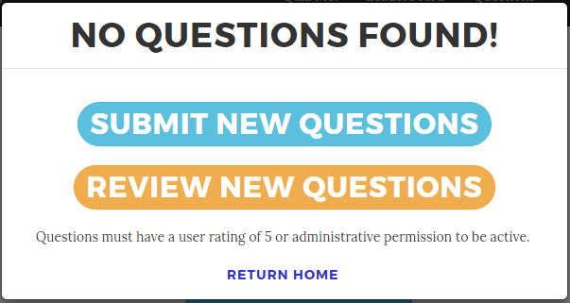

Otherwise the user will be shown the Get Ready popup that will allow them to start the quiz. This displays the number of questions found and the time allotted per question.

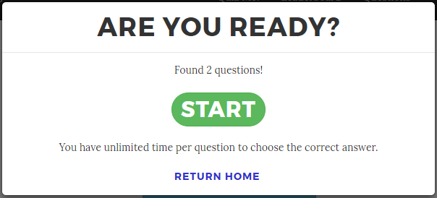

If there are questions available and the user clicks the Start button, they will be shown a screen similar to the following. Quizzes have the question order and answer order randomized so that users cannot just memorize the location of the correct answers.

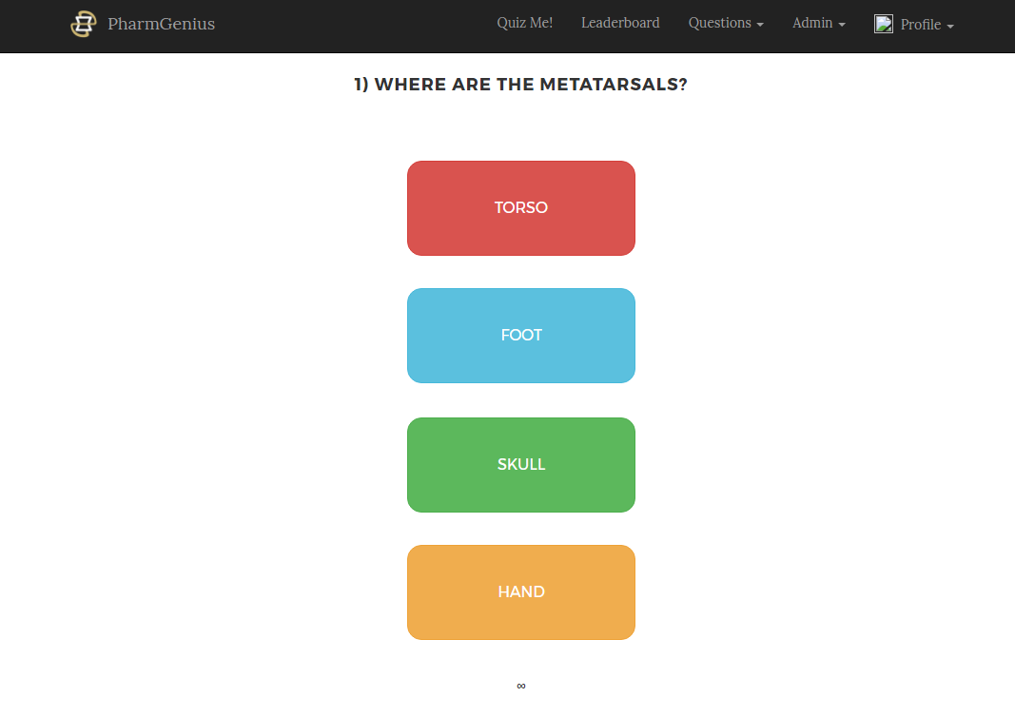

After answering a question, the user is shown the following popup with results about the question. The user may vote the question up or down, flag the question for review, and continue to the next question. An explanation will be shown if it exists, and the number of points earned will be displayed at the top of the page. The current points system assigns 100 points to each question as a base value, and each subsequent time the user answers the question correctly, they receive 90% of the score they previously earned. In this example, the user has answered correctly a number of times already. The correct answer is in green and the user selection is bolded. If a user has already reported a question, a message will be shown as such. A user may reset their vote either by clicking the reset vote link or using the thumbs up/thumbs down button to adjust which way they wish to vote.

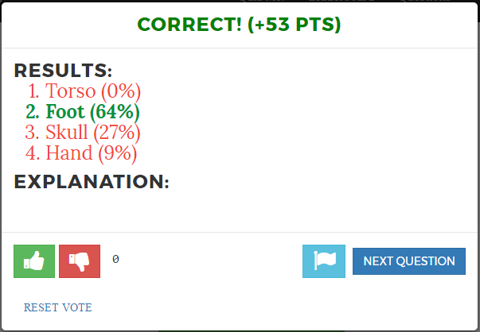

After all questions are answered, a summary screen will be displayed like the following. The Play Again button will replay the quiz, gathering a new random selection of questions. The Quiz Select button returns the user to the select quiz page.

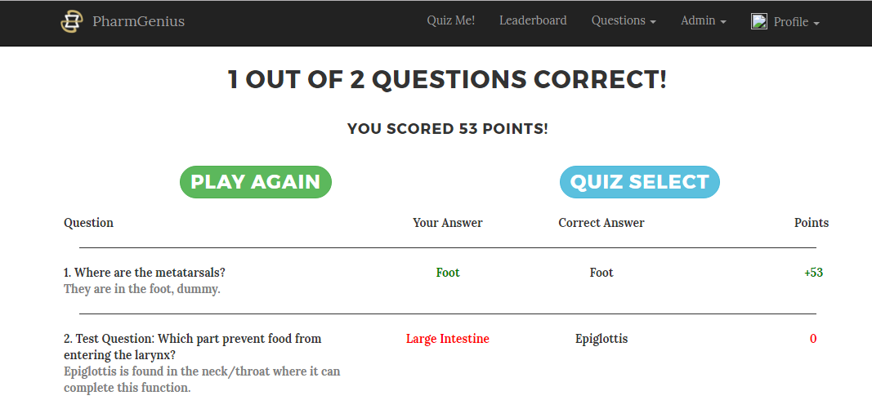

***Leaderboard – leaderboard.php***

This page displays a leaderboard of users for the site ranked by number of points. A number of filters can be set by using the dropdown boxes.

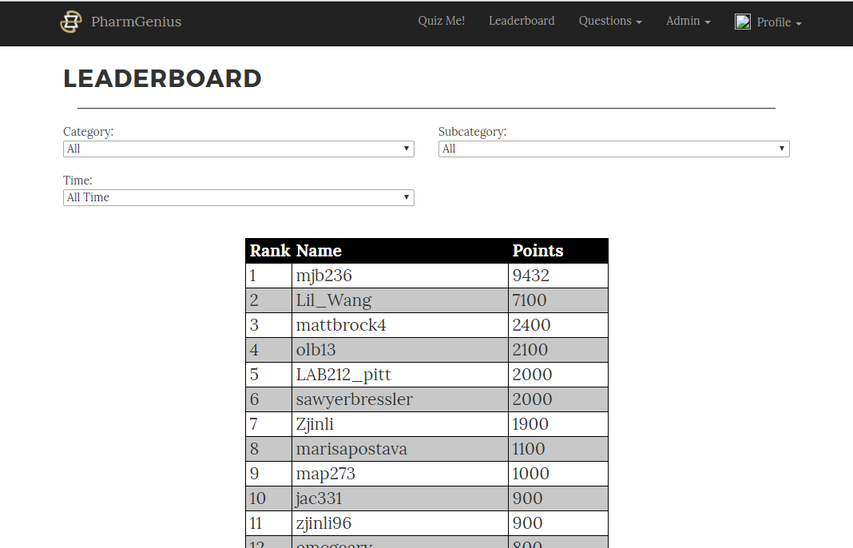

***Submit A Question – submit_new.php***

This page will allow a user to submit a new category, quiz for a category, and/or question for a quiz. The user may provide an explanation and image if desired. The question is submitted when the user fills the form out and clicks the corresponding colored button to select the correct answer.

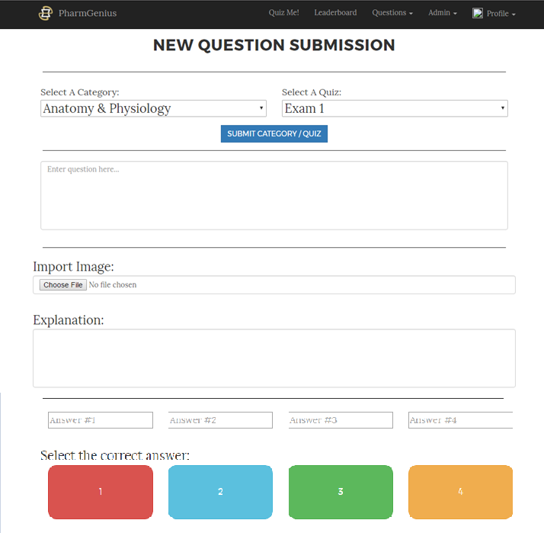

***Category Review – review_categories.php***

This page will allow an administrator to inactivate active categories or activate inactive categories.

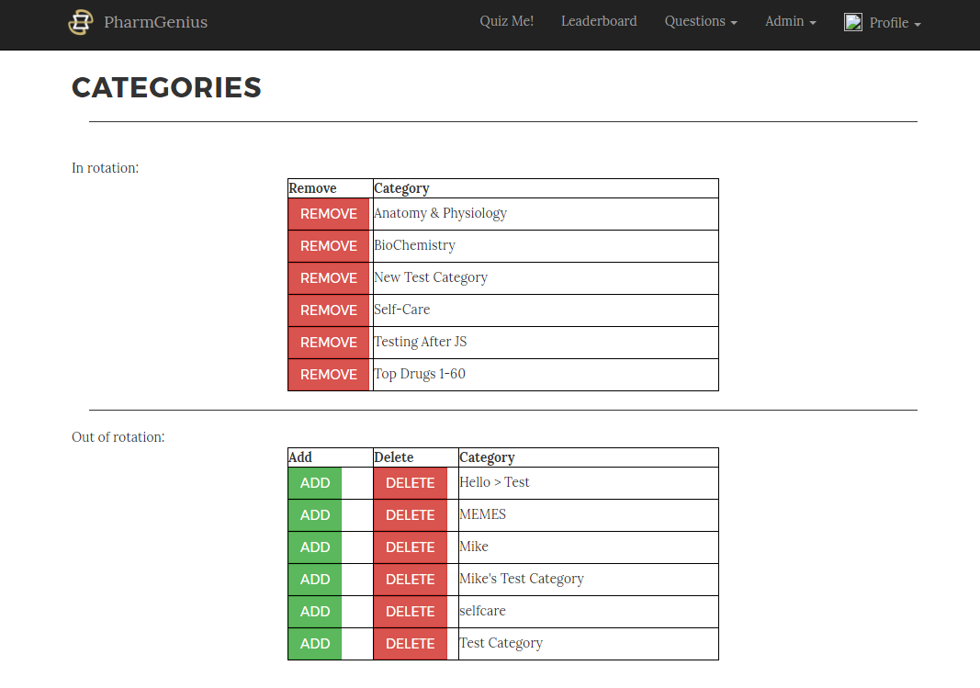

***Manage Users – manage_users.php***

The manage users pages allows admins to view the users that are currently registered for the site. They may also reset a user’s score and promote or demote users.

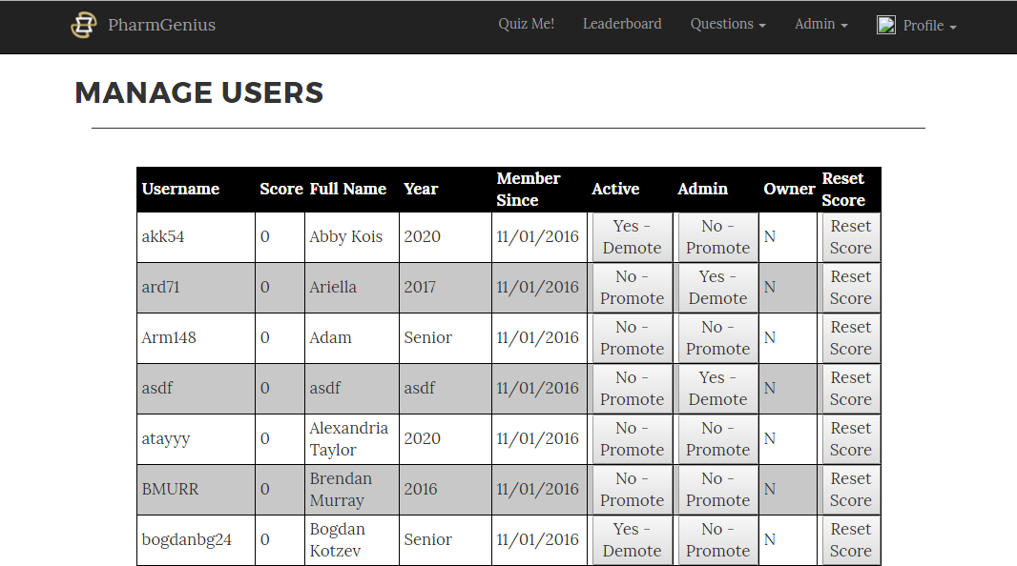

***Profile Page – profile.php***

This page allows a user to view their profile information, as well as edit that information or change their password. The popup for the change password function contains some basic validation to ensure that the old password is correct and that the new passwords match.

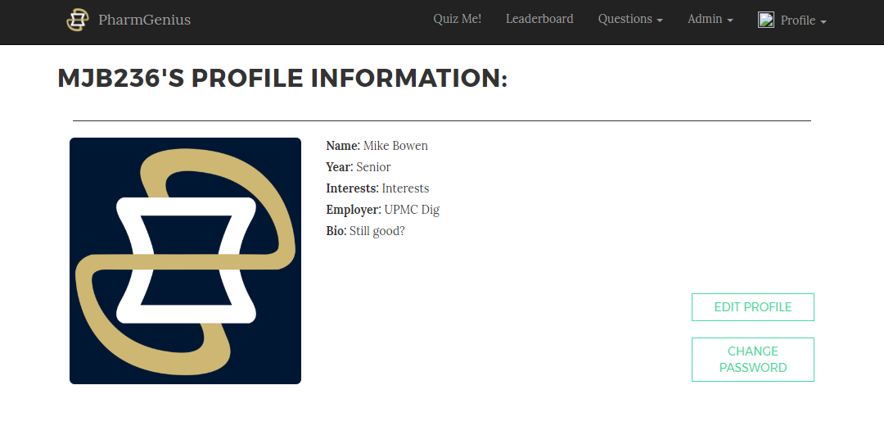

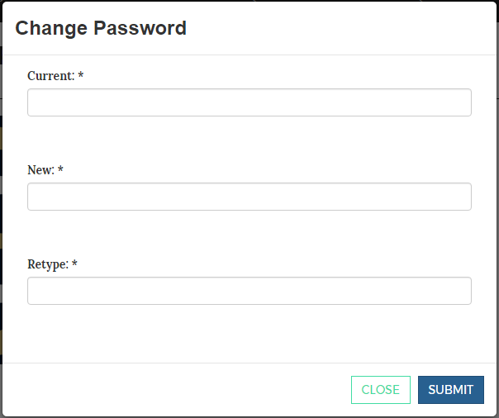

***Report Bug – footer.php, available on all pages, accessed by the Report Bug link in the Profile Dropdown***

The report bug modal allows a user to report a bug or make a suggestion about the site. This information is emailed to the administrators. This is accessible in all pages because it is in the footer.php file, which is included on all pages.

